INDIVIDUAL MODULE: BMW -FINANCE(S.A.HARDHINI)

using System;

using OpenQA.Selenium;

using OpenQA.Selenium.Chrome;

using OpenQA.Selenium.Firefox;

using OpenQA.Selenium.Edge;

using System.Threading;

using OpenQA.Selenium.Support.UI;

namespace linkedin_first

{

class Program

{

static IWebDriver driver;

static void Main(string[] args)

{

BMW();

}

static void BMW()

{

// Create reference for browser

driver = new ChromeDriver();

//Maximize the screen

driver.Manage().Window.Maximize();

//Giving URL

driver.Url = "https://www.bmw.in/en/index.html";

Thread.Sleep(2000);

// To Click Finance

//driver.FindElement(By.XPath("/ html / body / div[1] / div[2] / div / div / div[1] / div[3] / div / div[2] / div[4] / div / span[2]")).Click();

driver.FindElement(By.XPath("//*[@title='Finance']")).Click();

Thread.Sleep(2000);

//To click in Overview

driver.FindElement(By.XPath("/ html / body / div[1] / div[2] / div / div / div[2] / div / div[2] / div / div / div[5] / div / div[2] / div / a[1] / span")).Click();

//driver.FindElement(By.ClassName("ds2-second-level-label")).Click();

Thread.Sleep(2000);

// To view contact us

driver.FindElement(By.XPath("//*[@id='action-bar']/div/div/div[2]/a")).Click();

Thread.Sleep(2000);

ITakesScreenshot screenshotDriver = driver as ITakesScreenshot;

Screenshot screenshot = screenshotDriver.GetScreenshot();

screenshot.SaveAsFile("bmwss.png", ScreenshotImageFormat.Png);

Thread.Sleep(10000);

driver.Navigate().Back();

// To view EMI calculation

driver.FindElement(By.XPath("//*[@id='action-bar']/div/div/div[1]/a/div[2]")).Click();

Thread.Sleep(3000);

//Selection in EMI

driver.FindElement(By.XPath("//*[@id='event-file']/li[2]/a/div/label")).Click();

Thread.Sleep(2000);

//Select model in EMI

driver.FindElement(By.XPath("//*[@id='full-search']/div/div[2]/ul/li[1]/a")).Click();

Thread.Sleep(2000);

//Navigate back

driver.Navigate().Back();

Thread.Sleep(500);

//Navigate back

driver.Navigate().Back();

// Click Finance

//driver.FindElement(By.XPath("/ html / body / div[1] / div[2] / div / div / div[1] / div[3] / div / div[2] / div[4] / div / span[2]")).Click();

driver.FindElement(By.XPath("//*[@title='Finance']")).Click();

Thread.Sleep(2000);

//To click loan

driver.FindElement(By.XPath("/ html / body / div[1] / div[2] / div / div / div[2] / div / div[2] / div / div / div[5] / div / div[2] / div / a[2] / span")).Click();

//driver.FindElement(By.ClassName("ds2-second-level-label")).Click();

Thread.Sleep(500);

//Navigate back

driver.Navigate().Back();

////To click watch film

//driver.FindElement(By.XPath("/ html / body / div[4] / main / div[1] / div[3] / div[1] / div / div[1] / div / div / div[3] / ul / li / a / span[2]")).Click();

//Thread.Sleep(500);

// Click Finance

//driver.FindElement(By.XPath("/ html / body / div[1] / div[2] / div / div / div[1] / div[3] / div / div[2] / div[4] / div / span[2]")).Click();

driver.FindElement(By.XPath("//*[@title='Finance']")).Click();

Thread.Sleep(500);

//To view Lease

driver.FindElement(By.XPath("/ html / body / div[1] / div[2] / div / div / div[2] / div / div[2] / div / div / div[5] / div / div[2] / div / a[3] / span")).Click();

Thread.Sleep(500);

// For test drive

driver.FindElement(By.XPath("/html/body/div[4]/div[6]/ul/li[2]/a/span[2]")).Click();

SelectElement name = new SelectElement(driver.FindElement(By.XPath("//*[@id='bmw_salutation']")));

name.SelectByValue("Mr.");

//enter firstname

driver.FindElement(By.XPath("//*[@id='bmw_firstname']")).SendKeys("sudarsan");

//enter lastname

driver.FindElement(By.XPath("//*[@id='bmw_lastname']")).SendKeys("kumar");

//enter gmail

driver.FindElement(By.XPath("//*[@id='bmw_email']")).SendKeys("aab@gmail.com");

//enter mobile number

driver.FindElement(By.XPath("//*[@id='bmw_mobile1']")).SendKeys("1234567890");

// To select preffered model

SelectElement pm = new SelectElement(driver.FindElement(By.XPath("//*[@id='bmw_series']")));

pm.SelectByValue("2GC");

// To select Prefferd city

SelectElement city = new SelectElement(driver.FindElement(By.XPath("//*[@id='bmw_cityid']")));

city.SelectByValue("Chennai");

Thread.Sleep(500);

//Navigate back

driver.Navigate().Back();

Thread.Sleep(500);

//Navigate back

driver.Navigate().Back();

// Click Finance

//driver.FindElement(By.XPath("/ html / body / div[1] / div[2] / div / div / div[1] / div[3] / div / div[2] / div[4] / div / span[2]")).Click();

driver.FindElement(By.XPath("//*[@title='Finance']")).Click();

//Thread.Sleep(2000);

driver.FindElement(By.XPath("/html/body/div[1]/div[2]/div/div/div[2]/div/div[2]/div/div/div[5]/div/div[2]/div/a[6]/span")).Click();

Thread.Sleep(500);

// To click buy now

driver.FindElement(By.XPath("//*[@id='action-bar']/div/div/div[3]/a")).Click();

Thread.Sleep(1000);

// To view new cars

driver.FindElement(By.XPath("//*[@id='navbarNavAltMarkup']/div/ul/li[2]/a")).Click();

Thread.Sleep(2000);

//Sorting

//SelectElement sort = new SelectElement(driver.FindElement(By.ClassName("ng-star-inserted")));

//sort.SelectByValue("2");

//filtering Options

driver.FindElement(By.XPath("//*[@id='mat-chip-list-4']/div/mat-chip[1]")).Click();

Thread.Sleep(2000);

driver.FindElement(By.XPath("//*[@id='mat-chip-list-10']/div/mat-chip[2]")).Click();

Thread.Sleep(2000);

//// Click Finance

////driver.FindElement(By.XPath("/ html / body / div[1] / div[2] / div / div / div[1] / div[3] / div / div[2] / div[4] / div / span[2]")).Click();

//driver.FindElement(By.XPath("//*[@title='Finance']")).Click();

////To click loan

//driver.FindElement(By.XPath("/ html / body / div[1] / div[2] / div / div / div[2] / div / div[2] / div / div / div[5] / div / div[2] / div / a[2] / span")).Click();

////driver.FindElement(By.ClassName("ds2-second-level-label")).Click();

//Thread.Sleep(500);

//driver.FindElement(By.Id("/html/body/div[4]/main/div[1]/div[3]/div[1]/div/div[1]/div/div/div[3]/ul/li/a/span[2]")).Click();

//// To quit the window

driver.Quit();

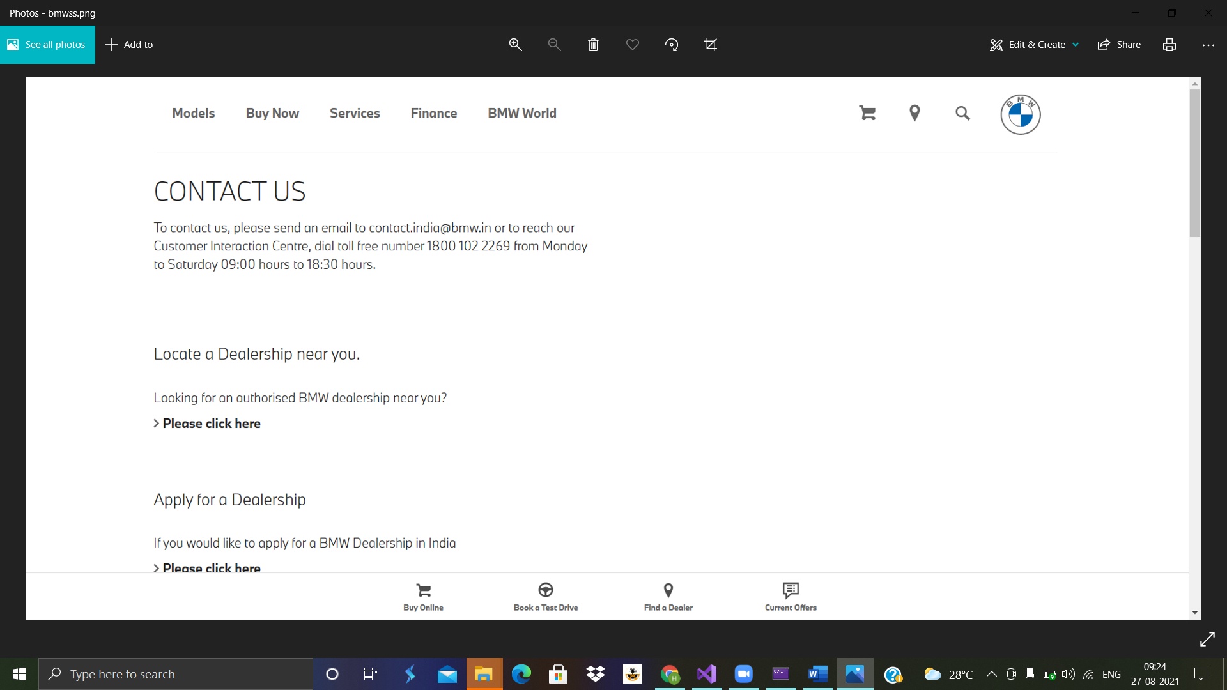

Screen shoT.bmwss